**Sprint-2**

|  |  |
| --- | --- |
| Date | 12 November 2022 |
| Team ID | PNT2022TMID24238 |
| Project Name | Industry-Specific Intelligent Fire Management System |

**MONITORING SENSOR VALUES**

**Display the temperature values in the dashboard:**

Submitted by: Rathidevi,Nandhini,Parwin,Preethi,Sathya

Student Roll number:810419104094,810419104067,810419104078,810419104091,810419104100

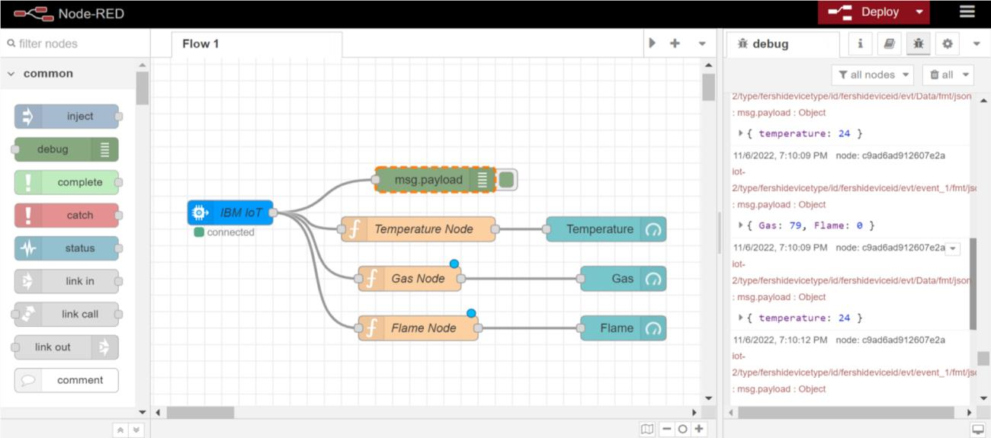

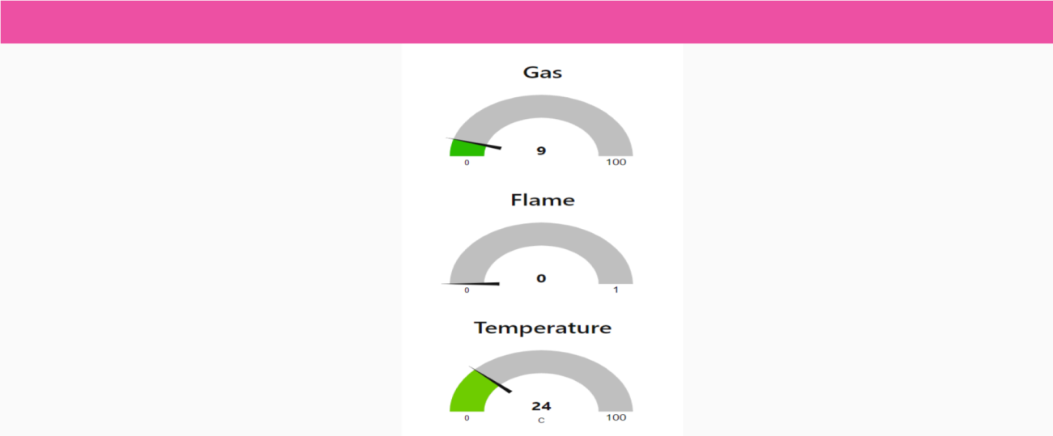

**Displaying flame sensor values:**

# SUBMITTED BY:RATHIDEVI(810419104094) ,PREETHI(810419104091),SATHYA(810419104100)

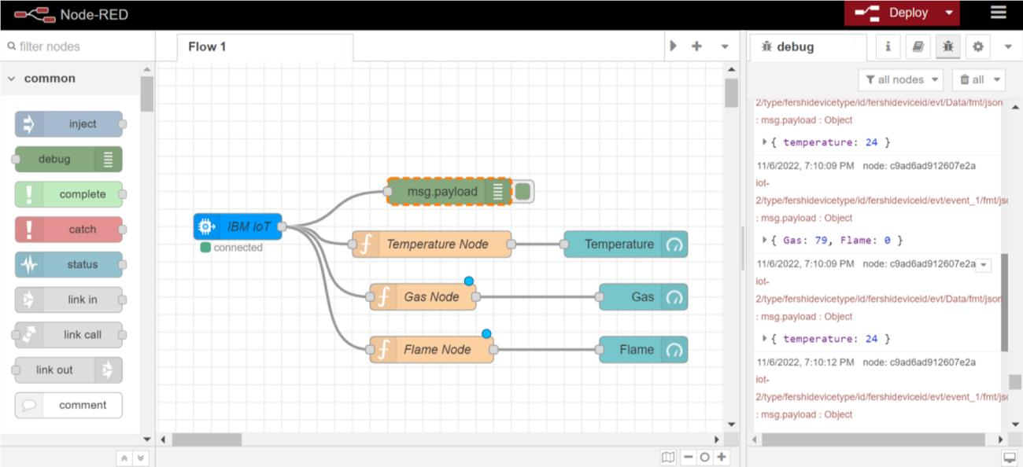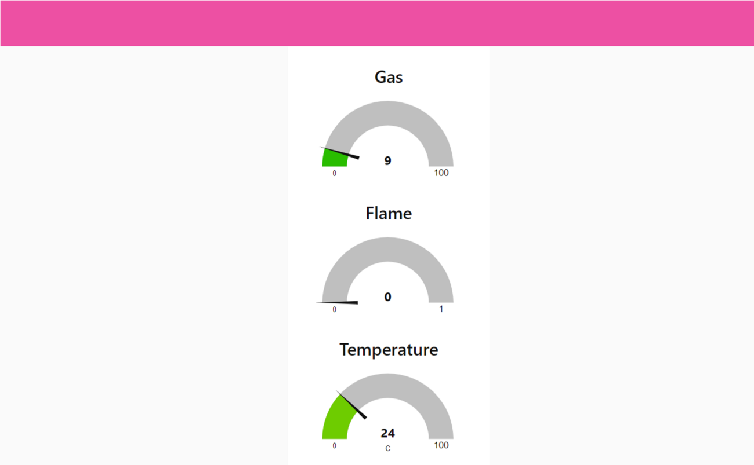

**Displaying gas sensor values:**

SUBMITTED BY:NANDHINI(810419104067),PARWIN(810419104078)

